**TY B.Tech. (CSE) – II [ 2020-21 ]**

**4CS372 : Advanced Database System Lab.**

**Assignment No. 3**

**Group ID:** 2018BCGRP10

**Batch:** T2

**Roll No:** 2018BTECS00072, 2018BTECS00086

**Title:**

Design and implement a web-enabled student MIS (Management Information System).

**Objective**: Use C#.Net / MySQL / Bootstrap v5.0.

**Introduction:**

**C#.NET:**

C# (C-Sharp) is a programming language developed by Microsoft that runs on the .NET Framework. C# is used to develop web apps, desktop apps, mobile apps, games and much more.

The C#.NET is one of the Microsoft programming languages. It is the most powerful programming language among all programming languages available in the .NET Framework. The C#.NET contains all the features of C++, VB.NET, JAVA, and also some additional features.

The C#.Net programming language is designed to be a simple, modern, general-purpose, and completely object-oriented programming language.

**MySQL:**

**MySQL** is an open-source relational database management system (RDBMS). A relational database organizes data into one or more data tables in which data types may be related to each other; these relations help structure the data. SQL is a language programmers use to create, modify and extract data from the relational database, as well as control user access to the database.

In addition to relational databases and SQL, an RDBMS like MySQL works with an operating system to implement a relational database in a computer's storage system, manages users, allows for network access and facilitates testing database integrity and creation of backups.

**Bootstrap v5.0:**

Bootstrap is a free and open-source CSS framework directed at responsive, mobile-first front-end web development. It contains CSS- and (optionally) JavaScript-based design templates for typography, forms, buttons, navigation, and other interface components.

Adding bootstrap to application:

    <link rel="stylesheet" href="https://stackpath.bootstrapcdn.com/bootstrap/4.1.3/css/bootstrap.min.css" integrity="sha384-MCw98/SFnGE8fJT3GXwEOngsV7Zt27NXFoaoApmYm81iuXoPkFOJwJ8ERdknLPMO" crossorigin="anonymous">

Above script is added in <head> </head> of the HTML page.

**Home page:**

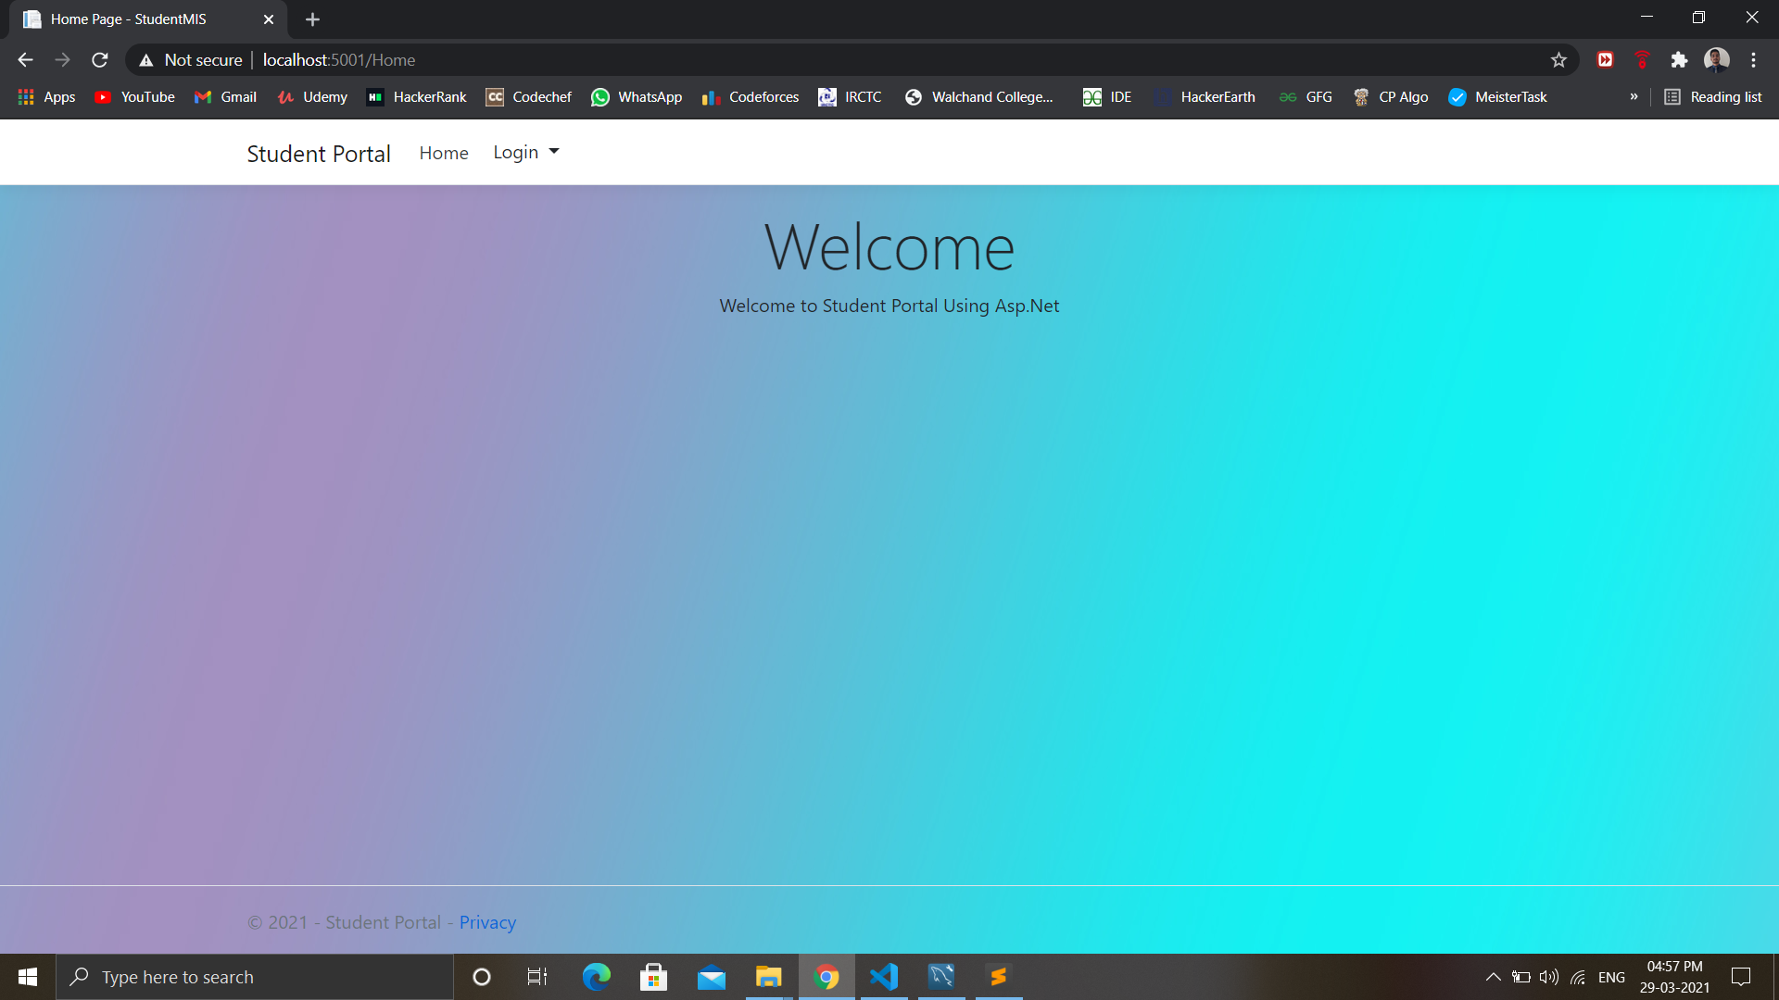

**Login page:**

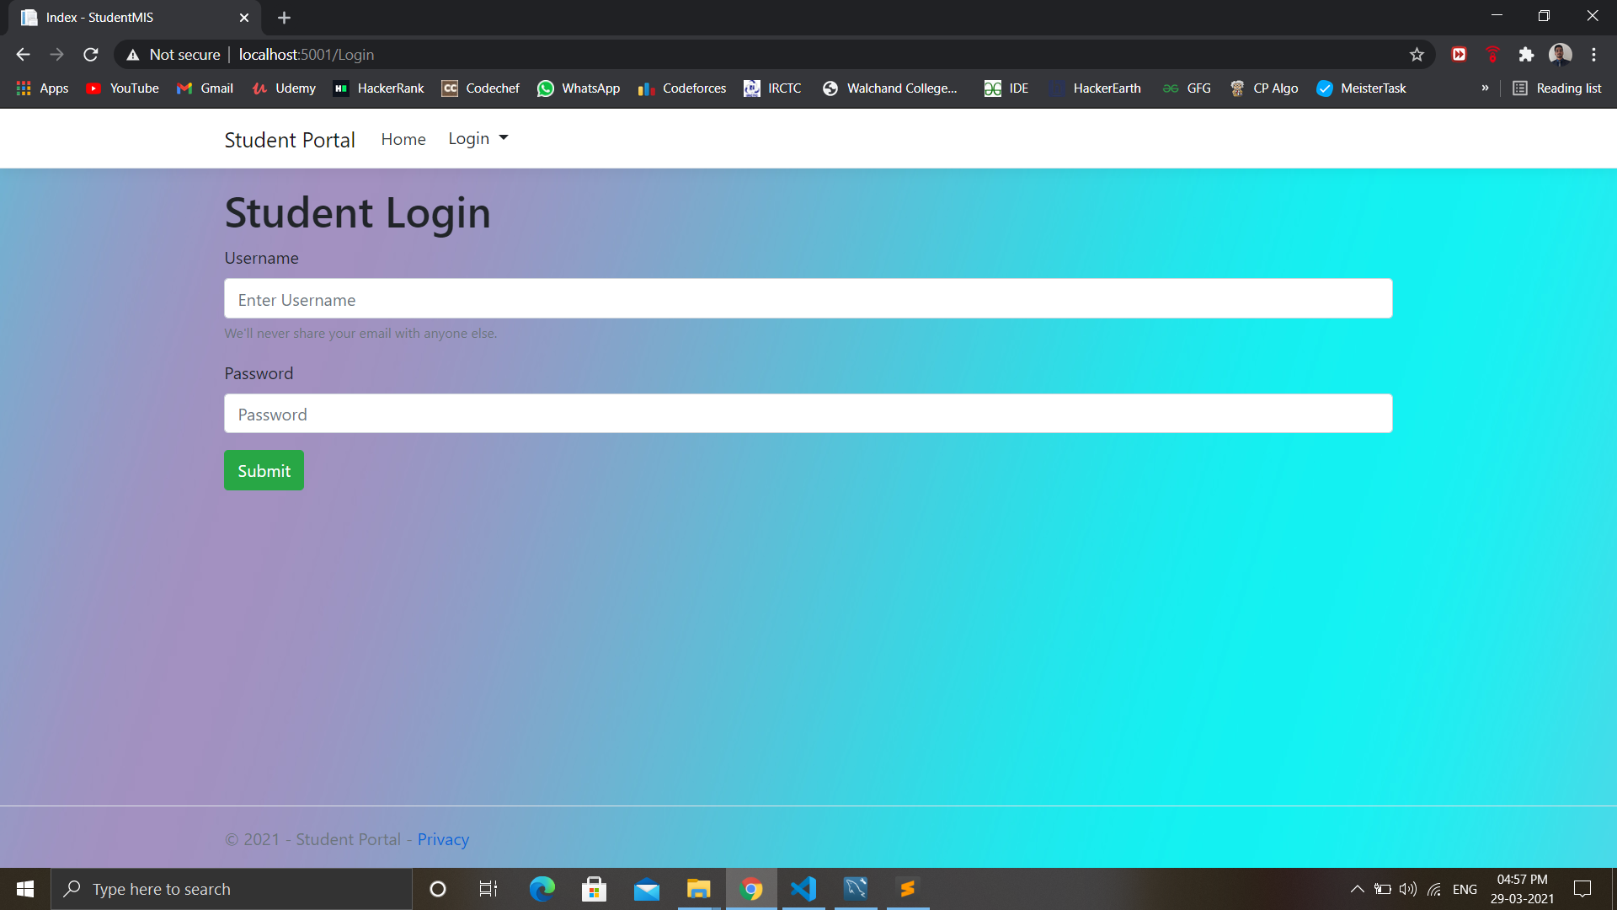

**Teacher Login:**

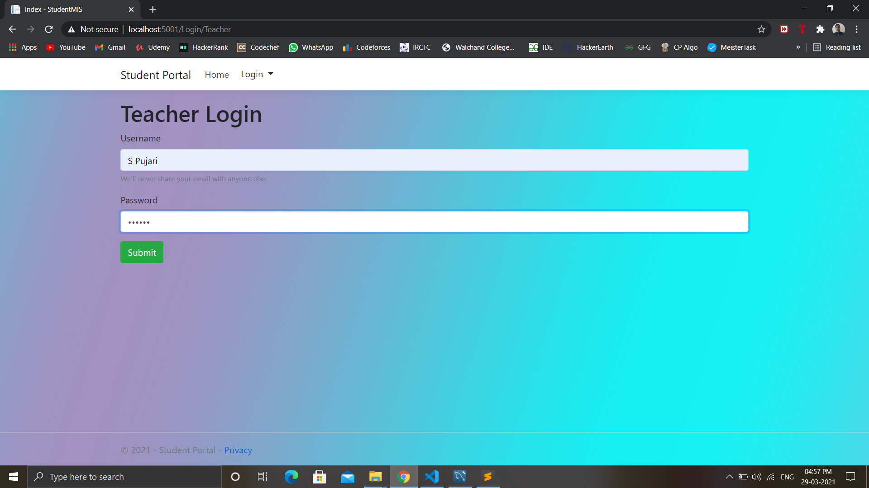

**Teacher Dashboard:**

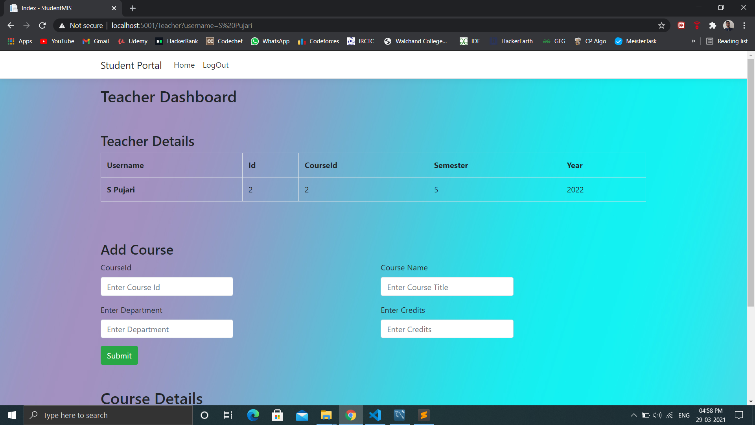

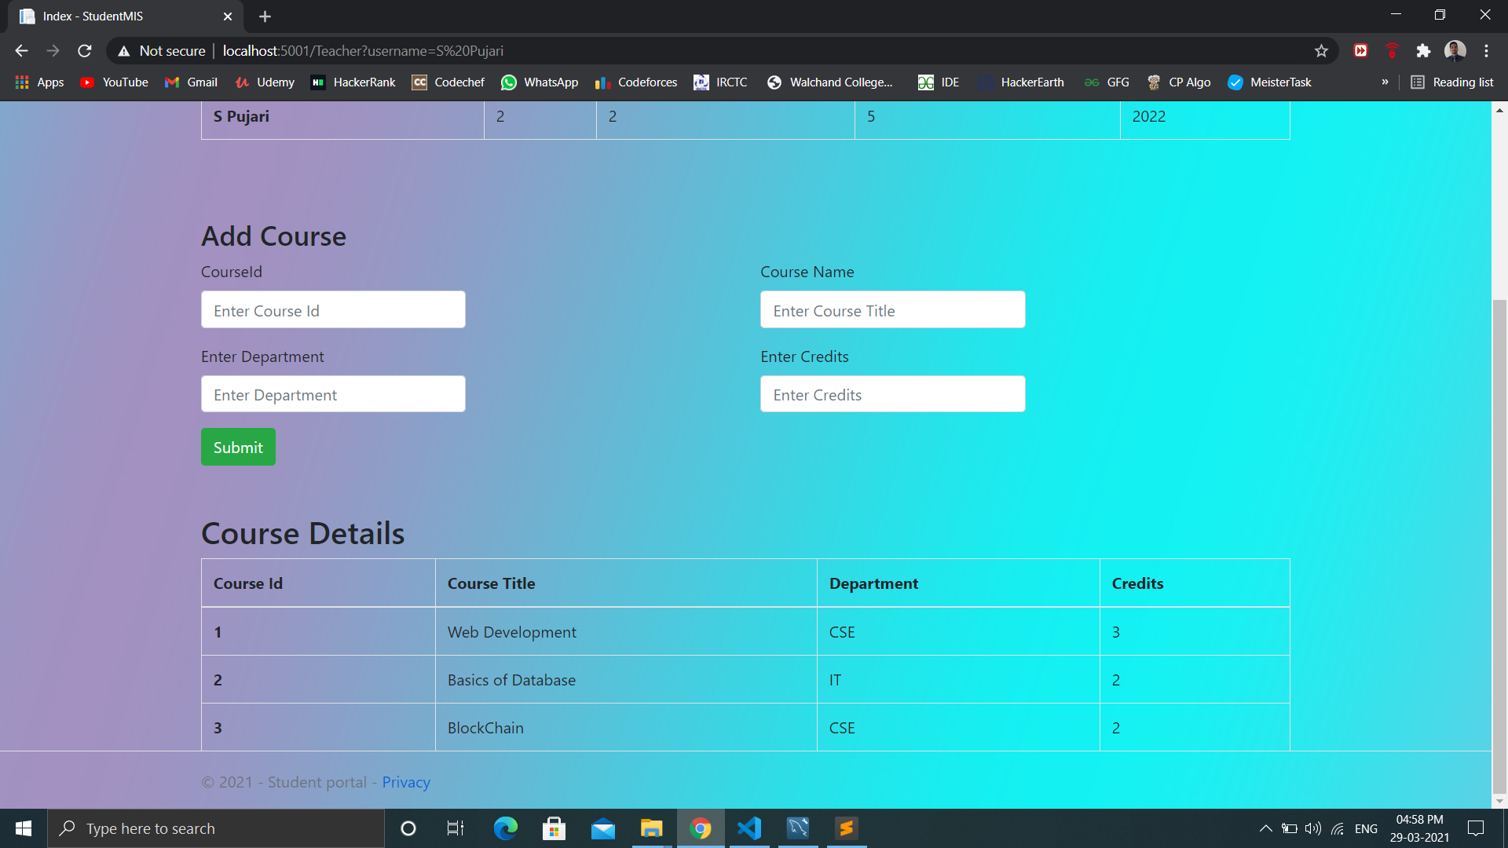

**Admin login:**

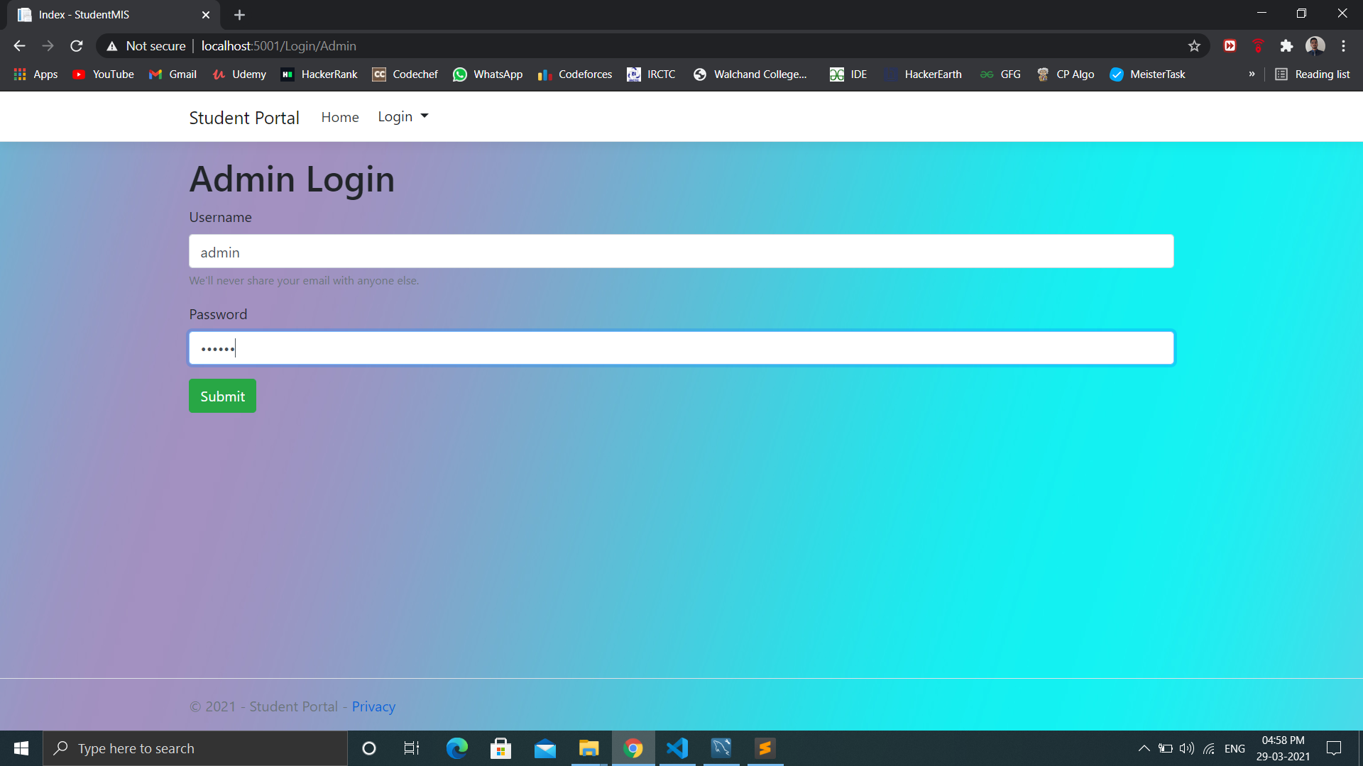

**Admin dashboard:**

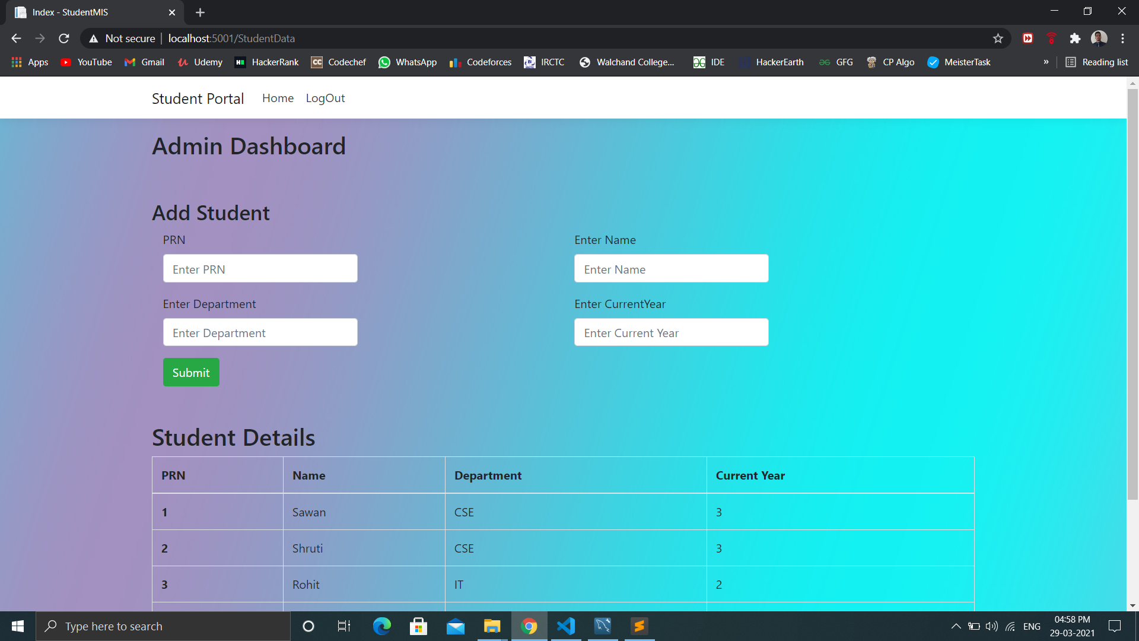

**Student dashboard:**

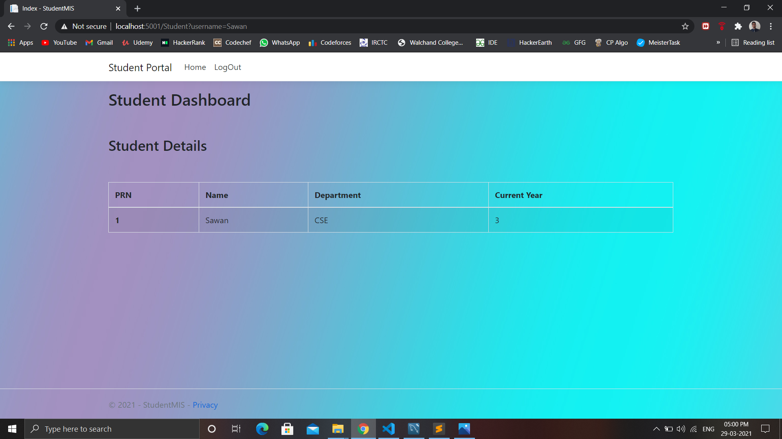

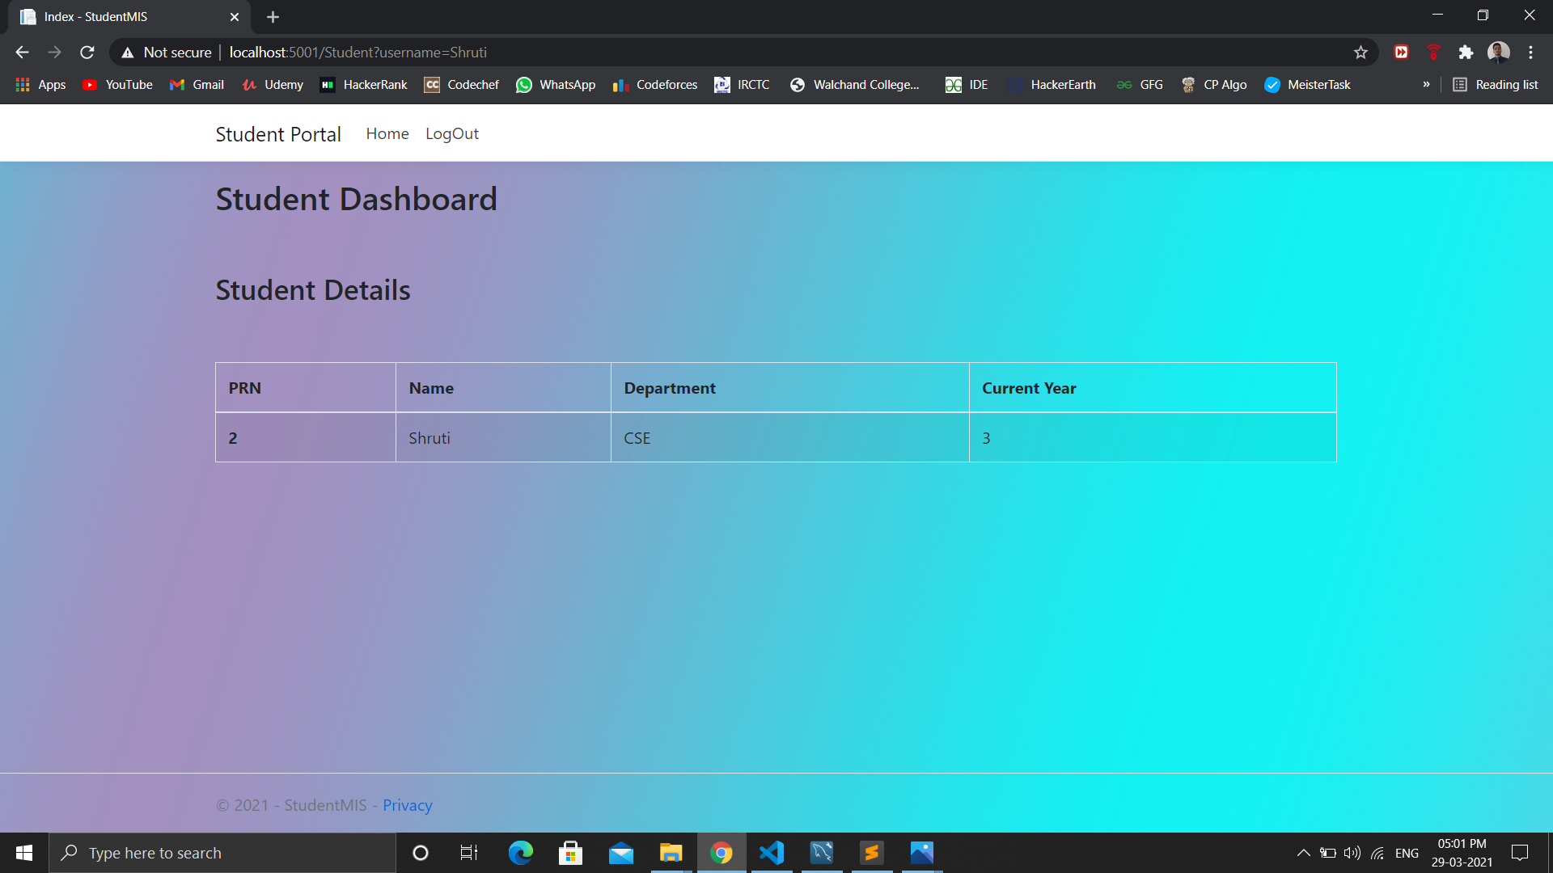

**Conclusion:**

C#.Net application was developed for the Student Information Management System with the help of Bootstrap5 as a front-end framework and MySQL as backend database.